Juvenile Photograph E-Filing Protocol

1. DCF presently takes a photo of a child in DCF custody as a matter of course. That photo will be e-filed as a separate document when DCF e-files the first caseplan (initial or disposition) for the child. Instructions regarding how to insert the photograph into the Juvenile Photograph Template Word document are printed below.

2.  A separate option (“Photograph – Juvenile”) has been added to the drop down list available to DCF case workers when they e-file. A screen shot of the new drop down choice is printed below.

3.  When the juvenile docket clerk processes the photograph document, a "sealed" security level will be given the document, such that only the judge can view the document.

4.   DCF will e-file an updated photograph each time that DCF e-files a permanency plan for the child thereafter.

5.   The Rutland DCF office will pilot the new process. The process will be rolled out to the other DCF offices and family divisions after sufficient time has passed to address any issues or glitches.

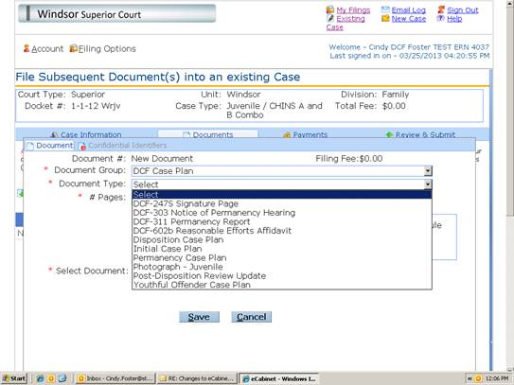

Instructions for Inserting a Photograph in the Juvenile Photograph Template

1. Open the Juvenile Photograph Template and complete upper portion.

2. Click where you want to insert the photograph.

3. Click “Insert”, click “Picture” and locate the folder where you have saved the photograph.

4. Double click the photograph you want to insert.

5. Click “Save As” and type the file name of your choosing.

6. Attach as a separate document under the “DCF Case Plan” category and the “Photograph-Juvenile” choice hen you e-file the first case plan (and subsequent permanency case plans) for the child.