E-Filing Juvenile Case Plans
DCF Caseworker

To File a Document Electronically

- Log on to www.vermontjudiciary.org and click the eFiling icon.

- Click Electronic Filing & Registration.

- Log in with the User Name and Password that have been provided to you by email. (Suggestion: save this site to your web browser’s favorites for quick access in the future.)

- Click Existing Case.

- Select
Type of Court: | Superior
Unit: | (Appropriate County)
Division: | Family
Docket #: | Enter docket number, following example – e.g., 1-10-13 rdjv
Click Search.
Type in Instructions, if there is particular information you wish to convey to the Juvenile Docket Clerk about what you are filing.

Click Next.

- Click Add Document.

- Select
Document Group: | DCF Case Plan (unless filing an amended or corrected case plan, in which case choose Amendments or Corrections, as the case may be. A case plan is considered amended only if changes have been made to it whereby the goal has changed. A case plan is considered corrected if changes have been made which do not change the goal.
Document Type: | Click the type of case plan (or attachment to a se plan, including a photograph of the juvenile) you are filing. Instructions on how to e-file a photograph appear at the end of these instructions.

Enter # of pages in the document being filed.
Public Access Rule 6 – select No.
Click Browse to locate and attach your document.
Click Save.

- Repeat Add Document process, if applicable. If not, click Next.

- Click Next.

- Click Submit.

- Click Sign Out

Note: If hand-written changes are made to a case plan, those changes should be incorporated in the case plan in italics or boldface before the case plan is e-filed. Caseworkers can electronically sign their case plans by typing “s/caseworker’s name” above the signature line.

Instructions for Inserting a Photograph in the Juvenile Photograph Template

1. Open the Juvenile Photograph Template and complete upper portion.
2. Click where you want to insert the photograph.
3. Click “Insert”, click “Picture” and locate the folder where you have saved the photograph.
4. Double click the photograph you want to insert.
5. Click “Save As” and type the file name of your choosing.
6. Attach as a separate document when you e-file the first case plan (and subsequent permanency case plans) for the child.

To View Documents You Have Filed Electronically to Date:

- Click My Filings in the upper right hand corner of any of the filing screens. Filter the date span according to your needs. Click the green circling arrows to the right of the date fields to initiate the search. A chronological list of documents you have e-filed will appear. (If you change the date parameters, click the green arrows to the right of the date fields to refresh the screen and re-search.)

- To view a particular document in the list, click on the underlined numeral in the first column.

To View E-Mails That Have Been Sent to You by eCabinet:

- Click Email Log in the upper right-hand corner of any of the filing screens. A chronological list of
the e-mails that have been sent to you will appear.

To view a particular e-mail, click to highlight the e-mail and scroll down.

To Modify Your User Name/Contact Information or Change Security Question:

- Log on to www.vermontjudiciary.org and click on the eFiling icon.

- Click on Electronic Filing & Registration.

- Log in with your User Name and Password.

- Click Account, then click My Profile.

- Click User Detail.

- Make whatever modifications you wish.

- Click Update.

To Change Your Password:

- Follow steps 1 – 4 immediately above.

- Click the Change Password tab.

- Follow prompts. Click Change.

To Change the Default Unit (County) of the Court Where you E-File:

- Follow steps 1 – 4 above.

- Click Preferences tab.

- Select County.

- Check Support Rich User Experience.

- Click Update.

For Additional Information:

An electronic version of the instructions can be found by scrolling to the bottom of the screen at:
https://www.vermontjudiciary.org/MasterPages/eservices-efiling.aspx

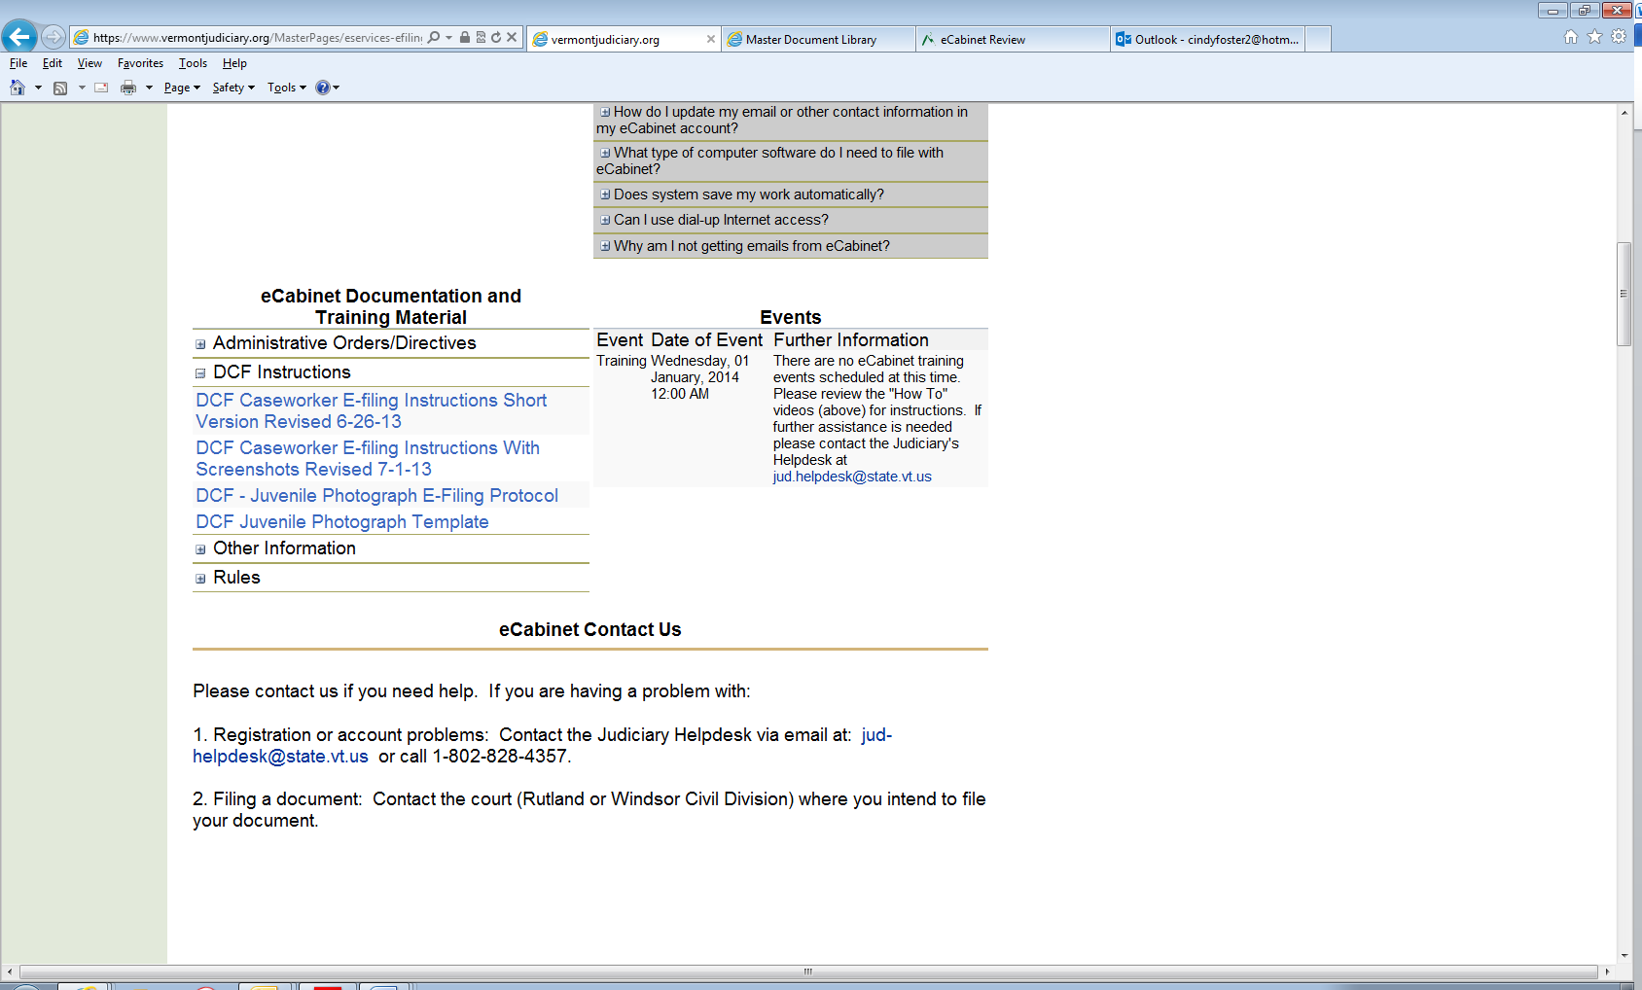

For help with eCabinet,
Please contact
JUD-Helpdesk@state.vt.us
802-828-4357

