E-Filing Juvenile Case Plans
DCF Caseworker

- Log on to www.vermontjudiciary.org and click on the eFiling icon.

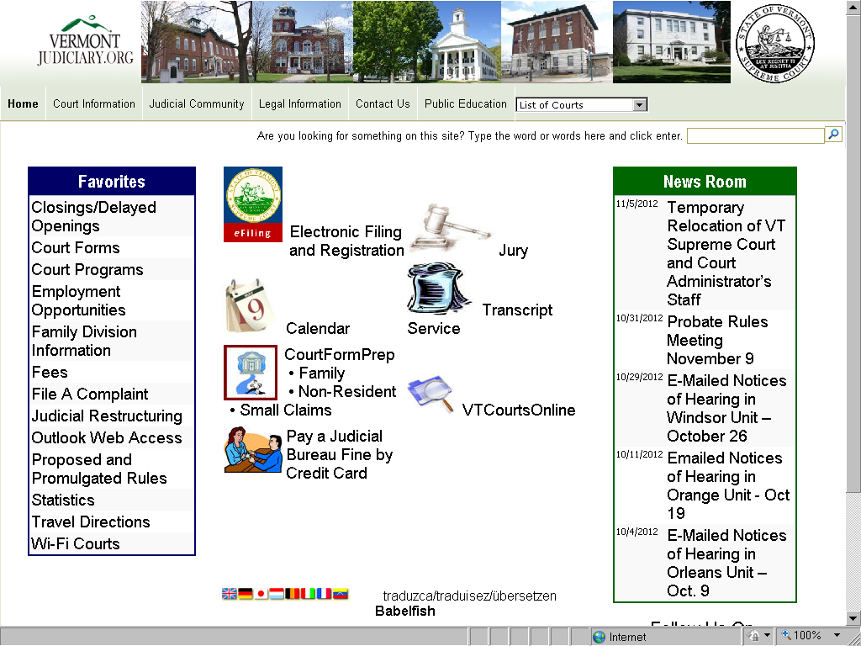

- On the Electronic Services screen, click Electronic Filing & Registration (in blue letters). (Note that there are Frequently Asked Questions and links to more information about e-filing on the Electronic Services page.)

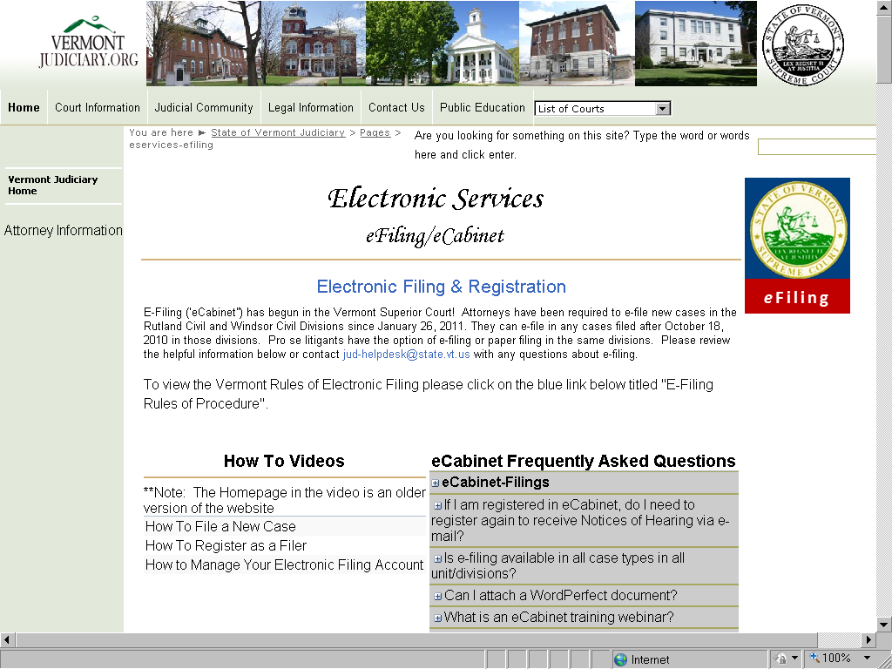

- Log in with the User Name and Password that have been provided to you by email. (Suggestion: save this site to your web browser’s favorites for quick access in the future.)

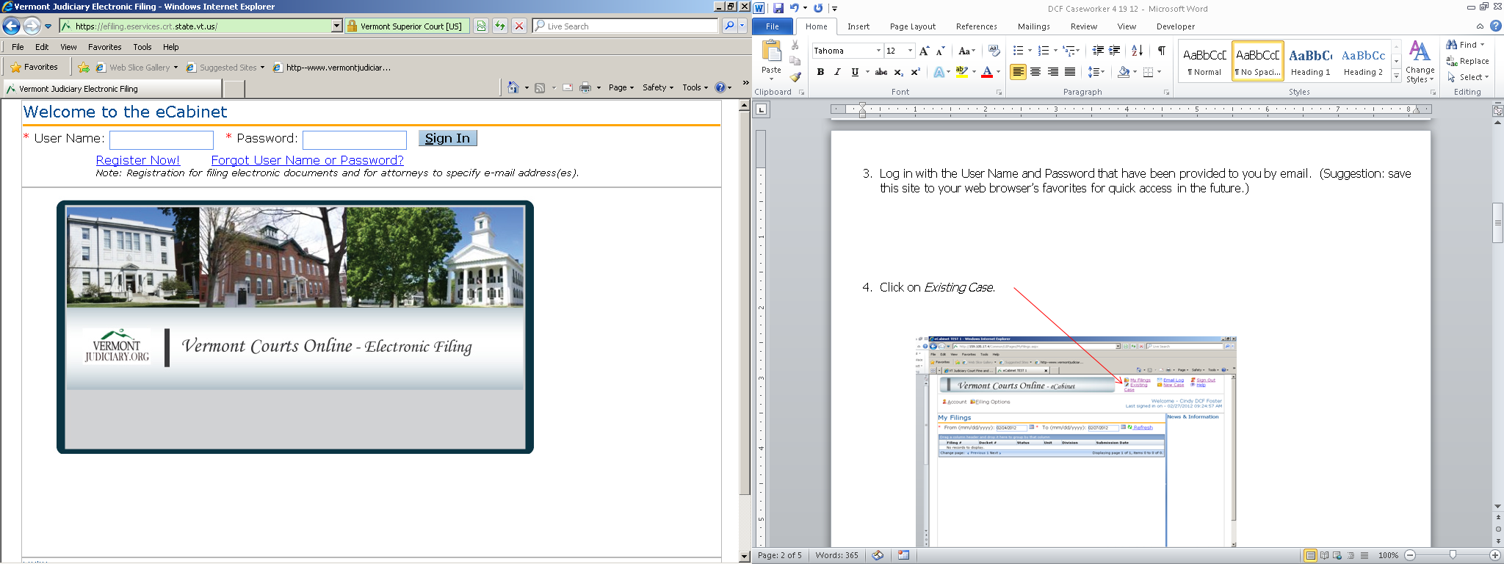

- Click Existing Case.

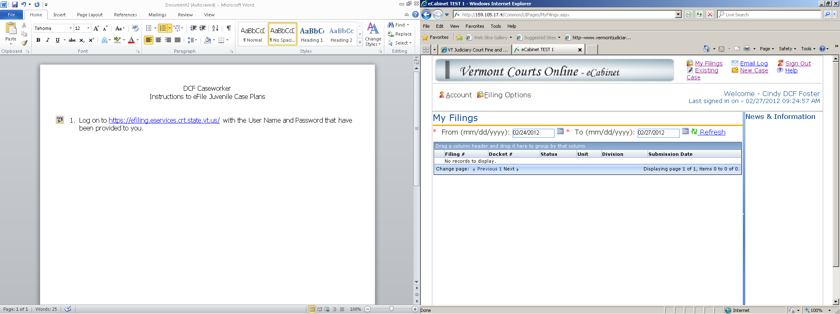

- Select Superior as the Type of Court, enter the appropriate Unit, then select Family as the Division. Enter the docket number, using the format indicated in the example (with one space between the last digit of the number and the first letter identifying the court.) The letters are not case sensitive. Click Search. Type in Instructions, if there is particular information you wish to convey to the Juvenile Docket Clerk about what you are filing. Click Next.

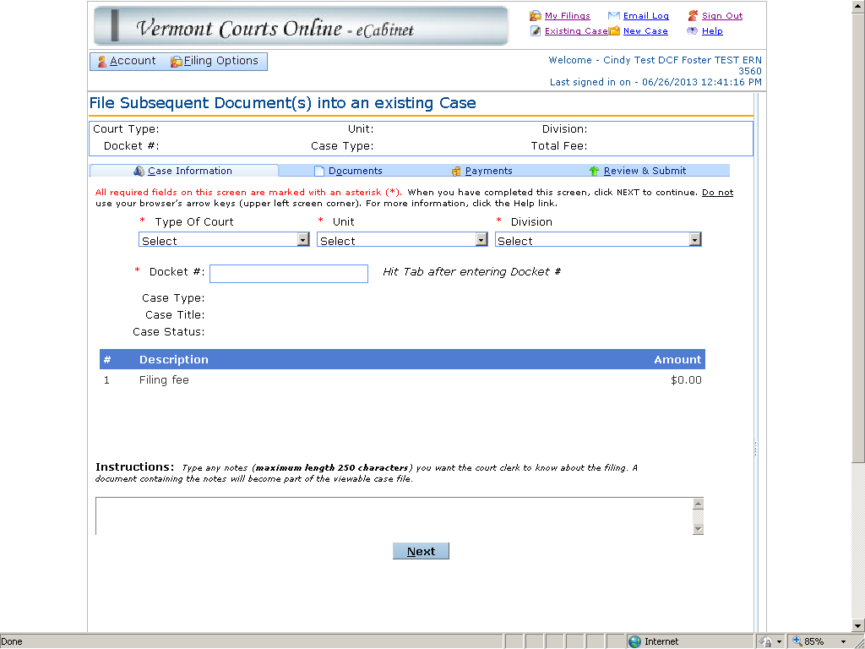

The screen will return with the Case Type and Case Title displayed next to the Docket Number. Confirm this is the correct case. (If it is not the correct case, confirm the docket number has been entered correctly. If not, you may re-enter the correct number and repeat the process to display the correct case.) If you have any problems or questions, please call 1-802-828-HELP or e-mail JUD-helpdesk@state.vt.us .

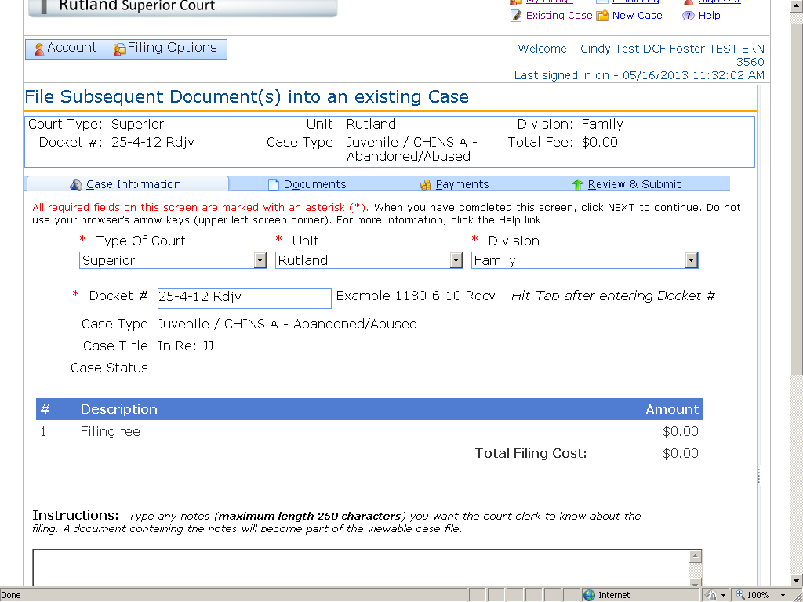

- Click Add Document.

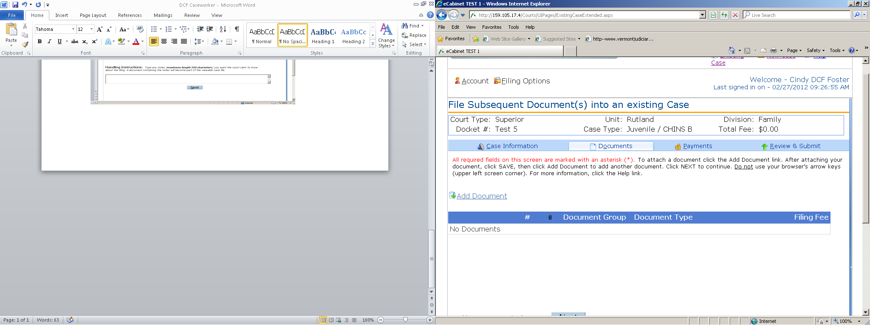

- Under Document Group, select DCF Case Plan (unless filing an amended or corrected case plan, in which case choose Amendments or Corrections, as the case may be. A case plan is considered amended only if changes have been made to it whereby the goal has changed. A case plan is considered corrected only if changes have been made to it which do not change the goal.

Click the type of case plan (or attachment to case plan, including juvenile photographs) you are filing from the Document Type drop down list pictured below. (Instructions on how to attach a juvenile photograph appear at the end of these instructions.)

Document Type Menu:
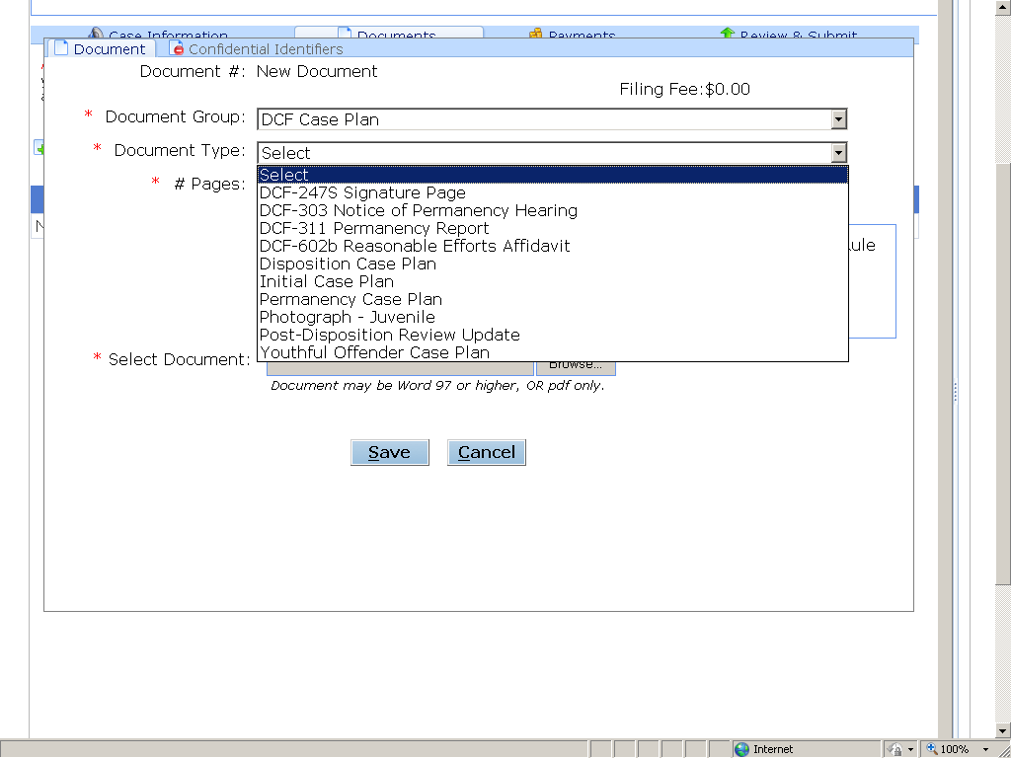

Next, indicate the number of pages in the document, click No for the Public Access Rule 6 question, then click Browse to locate and attach your document. Click Save.

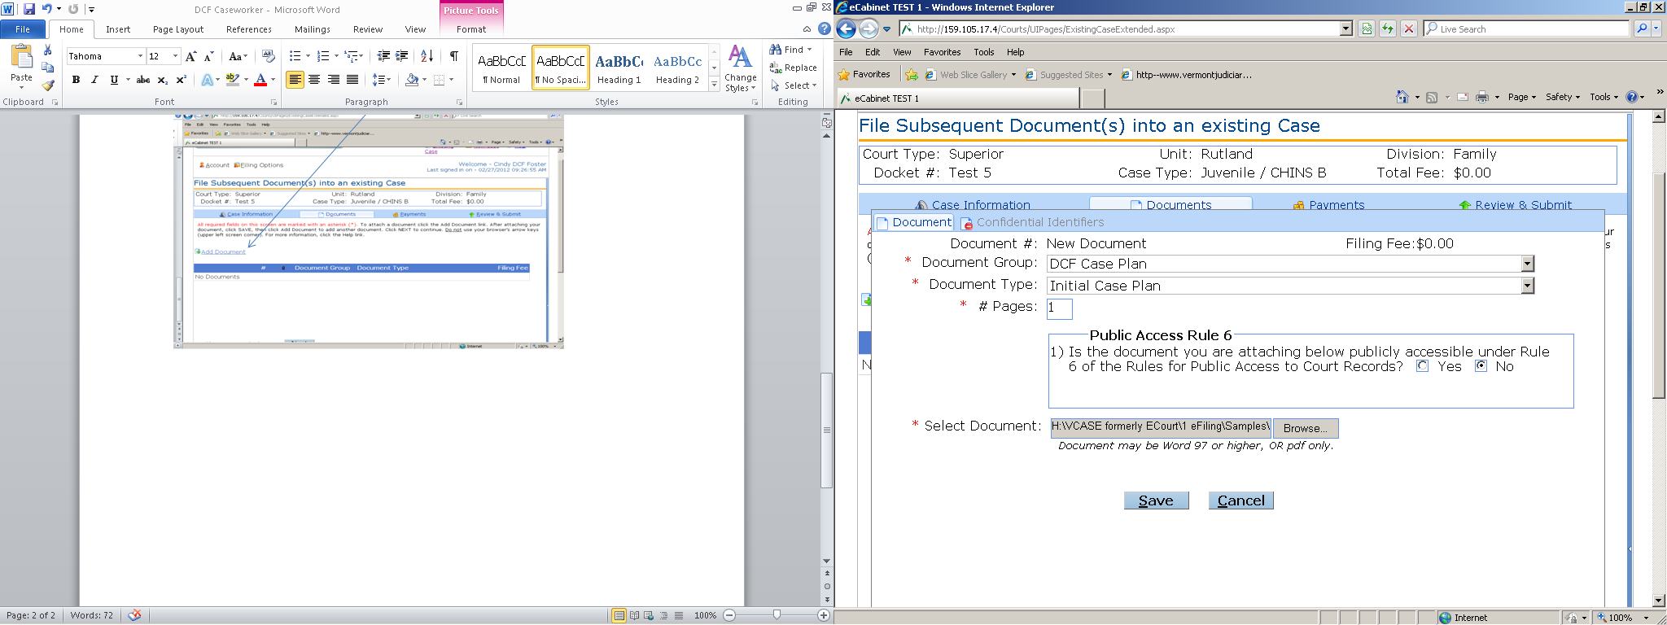

- A second Add Document screen will be displayed. If you wish to add another document, click Add Document and repeat the process. If you do not wish to add another document, click Next.

- The next screen is a Fee Information screen. Since no filing fee is associated with a DCF Case Plan, click Next.

- The following screen is a review screen. Follow instructions on the screen if you should need to make any adjustments to previous entries. Click Submit.

- A Filing Confirmation screen will be displayed, and you will receive an email confirmation as well. Click Sign Out.

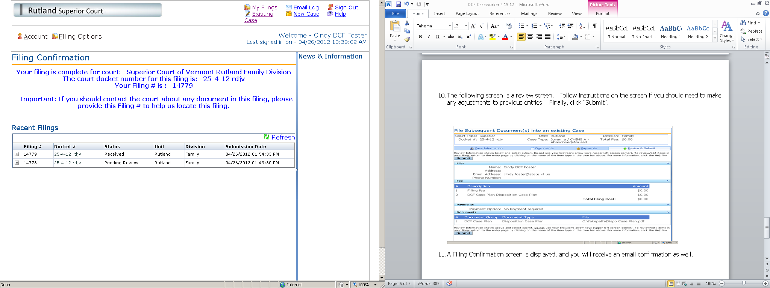

Text of Confirmation E-mail:
“Dear {DCF CASEWORKER}:
This email verifies the receipt of 1 document submitted by you to Rutland Family Division on MM/DD/YYYY, at 02:07:39 PM.
Docket Number: XX-X-XX Rdjv In RE: XX
The Reference number of this filing is: 14742. Please reference this Filing # in any correspondence. We will notify you when processing is complete.
This is a non-monitored email. Do not reply directly to it. If you have any questions about this filing please contact the Rutland Family Division.
Thank you,
Vermont Judiciary”

Note: If hand-written changes are made to a case plan, those changes should be incorporated in the case plan in italics or boldface before the case plan is e-filed. Caseworkers can electronically sign their case plans by typing “s/caseworker’s name” above the signature line.

Instructions for Inserting a Photograph in the Juvenile Photograph Template

1. Open the Juvenile Photograph Template and complete upper portion.
2. Click where you want to insert the photograph.
3. Click “Insert”, click “Picture” and locate the folder where you have saved the photograph.
4. Double click the photograph you want to insert.
5. Click “Save As” and type the file name of your choosing.
6. Attach as a separate document when you e-file the first caseplan (and subsequent permanency caseplans) for the child.

Other Functions

To View Documents You Have Filed Electronically to Date:

- Click My Filings in the upper right hand corner of the opening “My Filings” screen. Select a date range and click Refresh. A chronological list of your filings within that time frame will appear. For additional details about a given document, click on the “+” sign in the first column. Further details about the document will be displayed. To view the actual document, click on the underlined numeral in the first column.

(Note that while you may view “My Filings” from any of the filing screens, once you click on the “My Filings” link you may lose any data you have entered up to that point and may have to start again, so it is not advisable to use this function in the midst of the e-filing process..)

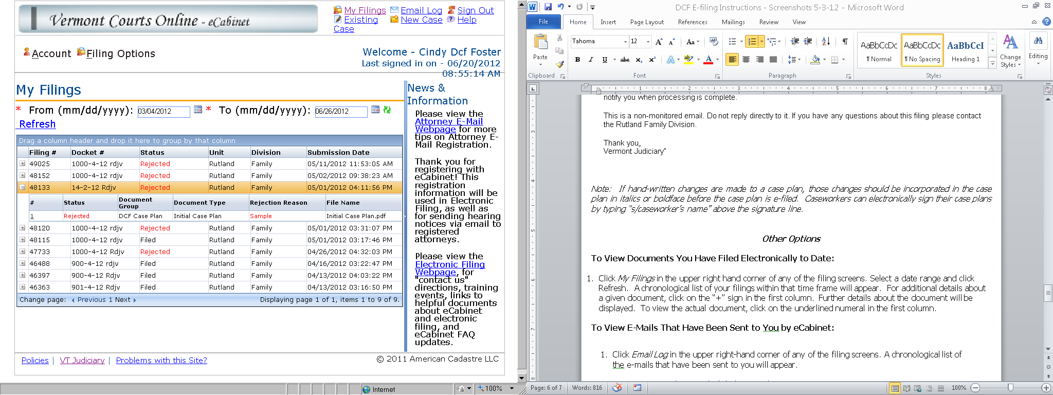

To View E-Mails That Have Been Sent to You by eCabinet:

- Click Email Log in the upper right-hand corner of any of the filing screens. A chronological list of
your system generated e-mails will appear. To view a particular e-mail, click to highlight the e-mail and scroll down.

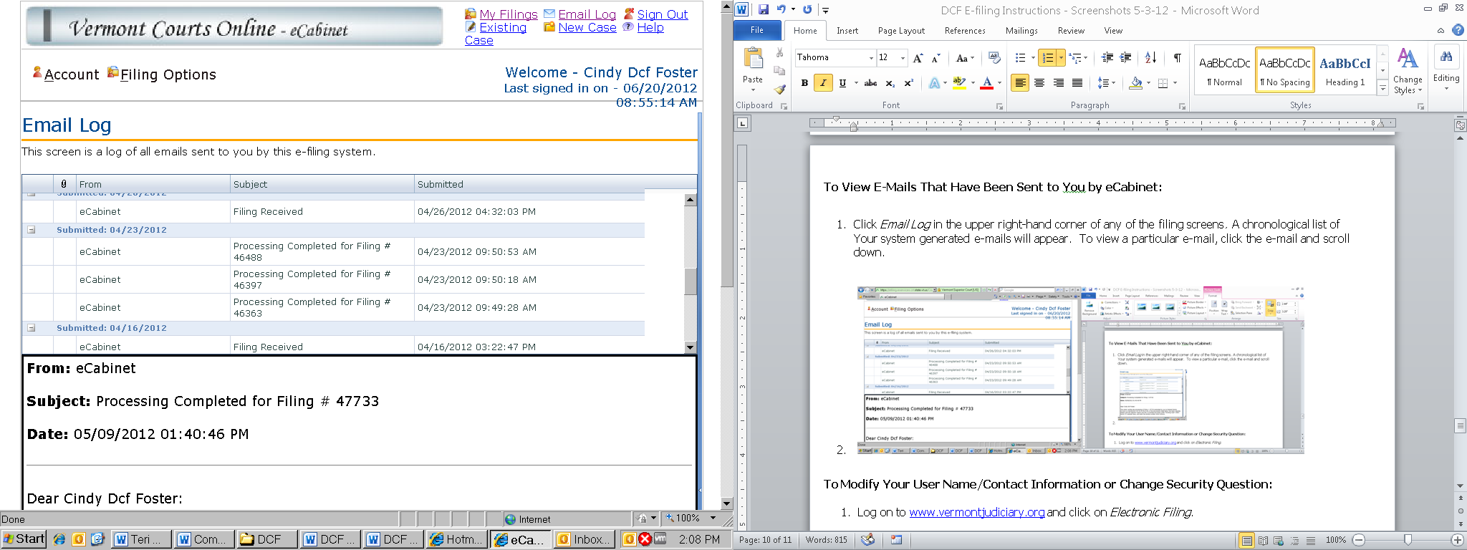

To Modify Your User Name/Contact Information or Change Security Question:

- Log on to www.vermontjudiciary.org and click on the eFiling icon.

- Click on Electronic Filing & Registration.
- Log in with your User Name and Password.

- Click Account, then click My Profile.

- Click User Detail.

- Make whatever modifications you wish.

- Click Update.

To Change Your Password:

- Follow steps 1 – 4 immediately above.

- Click the Change Password tab.

- Follow prompts. Click Change.

To Change the Default Unit (County) of the Court Where you E-File:

- Follow steps 1 – 4 above.

- Click Preferences tab.

- Select County.

- Check Support Rich User Experience.

- Click Update.

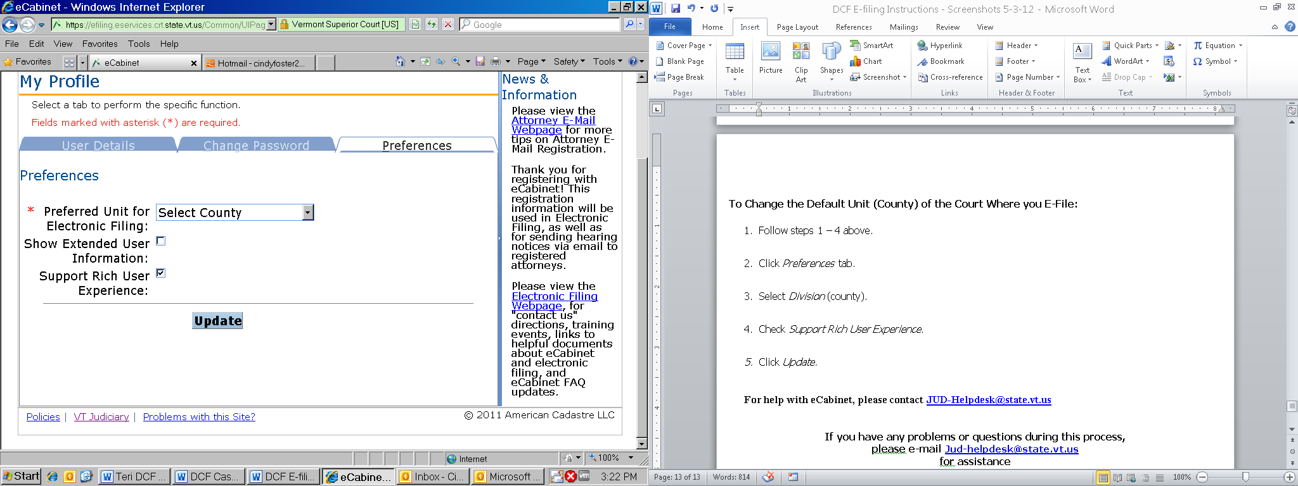

For Additional Information:

An electronic version of the instructions can be found by scrolling to the bottom of the screen at:
http://vermontjudiciary.org/MasterPages/eservices-efiling.aspx

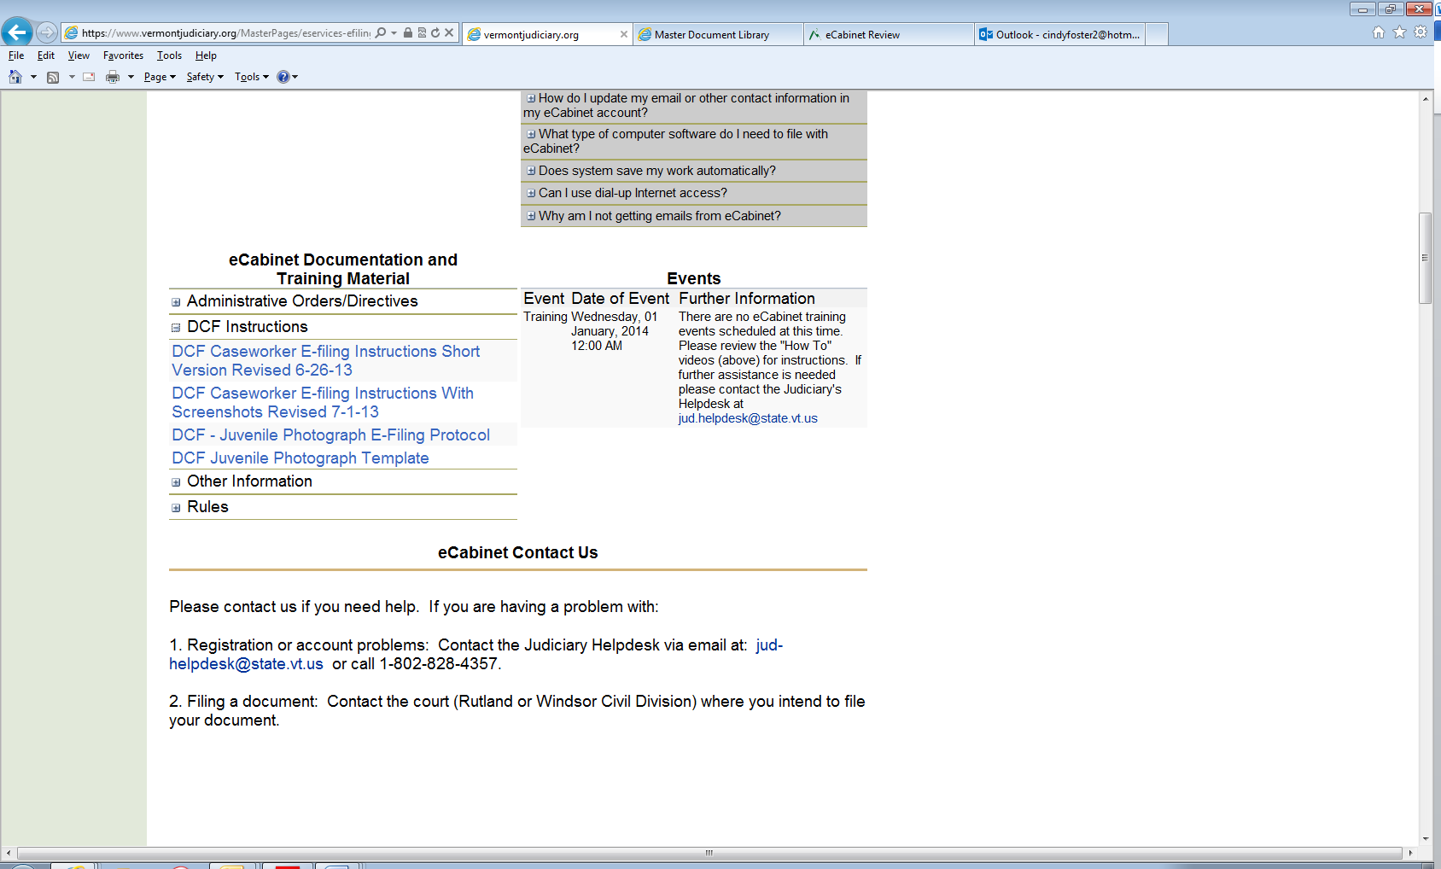

For help with eCabinet,
Please contact
JUD-Helpdesk@state.vt.us
802-828-4357

